

**Food Delivery System**

Hardware and Software Configuration Documentation

Jianhui Lu Weiran Yuan Li Chen

December 15, 2017

CONTENTS

PURPOSE 2

HARDWARE CONFIGURATION 2

RECOMMENDED HARDWARE CONFIGURATION 2

MINIMUM HARDWARE CONFIGURATION 3

SOFTWARE CONFIGURATION 3

REQUIRED SOFTWARE: 3

JDK 3

TOMCAT 8.0.48 5

ECLIPSE IDE FOR JAVA EE DEVELOPER 6

POSTGRESQL 7

BROWSER COMPATIBILITY 7

# PURPOSE

The configuration documentation aims to help users set up the environment so that our food delivery web application can compatibly run on your computers.

For hardware configuration, we provided recommendations and minimum system requirements to provide general guideline on which computer configurations work best in the Food Delivery System computing environment.

For software configuration, we provided guides to install the software needed for system. We also provided ways to configure the database so that the app can run on local computer, which means we were providing the way to set up the environment of configuring the food delivery system and the way to modify it on your own computer.

# HARDWARE CONFIGURATION

We provide recommended hardware configuration and minimum hardware configuration below. Basically, computers installed with suitable browsers and able to install Tomcat virtual server and Eclipse IDE can run our application and it won’t arose many compatibility problems.

## RECOMMENDED HARDWARE CONFIGURATION

|  |  |
| --- | --- |
| Processor (CPU): | Intel Core i5-6xxx or equivalent |
| Operating System: | Microsoft Windows 10 Professional x64 SP1/ macOS High Sierra Version 10.13.1 |
| Memory: | 8 GB RAM |
| Storage: | 256 GB internal hard drive |
| Monitor/Display: | 14" LCD monitor, resolution of 1600 x 900 or better. |
| Display Driver: | Intel(R) HD Graphics 520, NVDIA GeForce GTX 965M / Intel Iris Graphics 550 1536MB |
| Storage Controller | Microsoft Storage Spaces Controller / Apple Mac Pro RAID Card SATA 3Gb/s / SAS - PCIe x4 |

## MINIMUM HARDWARE CONFIGURATION

|  |  |
| --- | --- |
| Processor (CPU): | Intel Core i3-3xxx |
| Operating System: | Microsoft Windows 7 Professional x64 SP1 |
| Memory: | 4 GB RAM |
| Storage: | 256 GB internal hard drive |
| Monitor/Display: | 13" LCD monitor |
| Display Adapter: | Intel(R) HD Graphics 520 |

The recommended hardware configuration is the computer hardware configuration of the developers, so it would be perfectly compatible to this version of configuration.

# SOFTWARE CONFIGURATION

## REQUIRED SOFTWARE:

* Java Development Kit (JDK)
* Java Application Server – Tomcat 8.0.48
* Java Integrated Development Environment (IDE) – Eclipse IDE for Java EE Developers
* PostgreSQL
* Browser

## JDK

You’ll need a JDK as the Java environment so that you can run your java program on your computer.

Go to <http://www.oracle.com/technetwork/java/javase/downloads/index.html> to download JDK version higher than 8.0 and suitable to your OS, install the JDK to your computer.

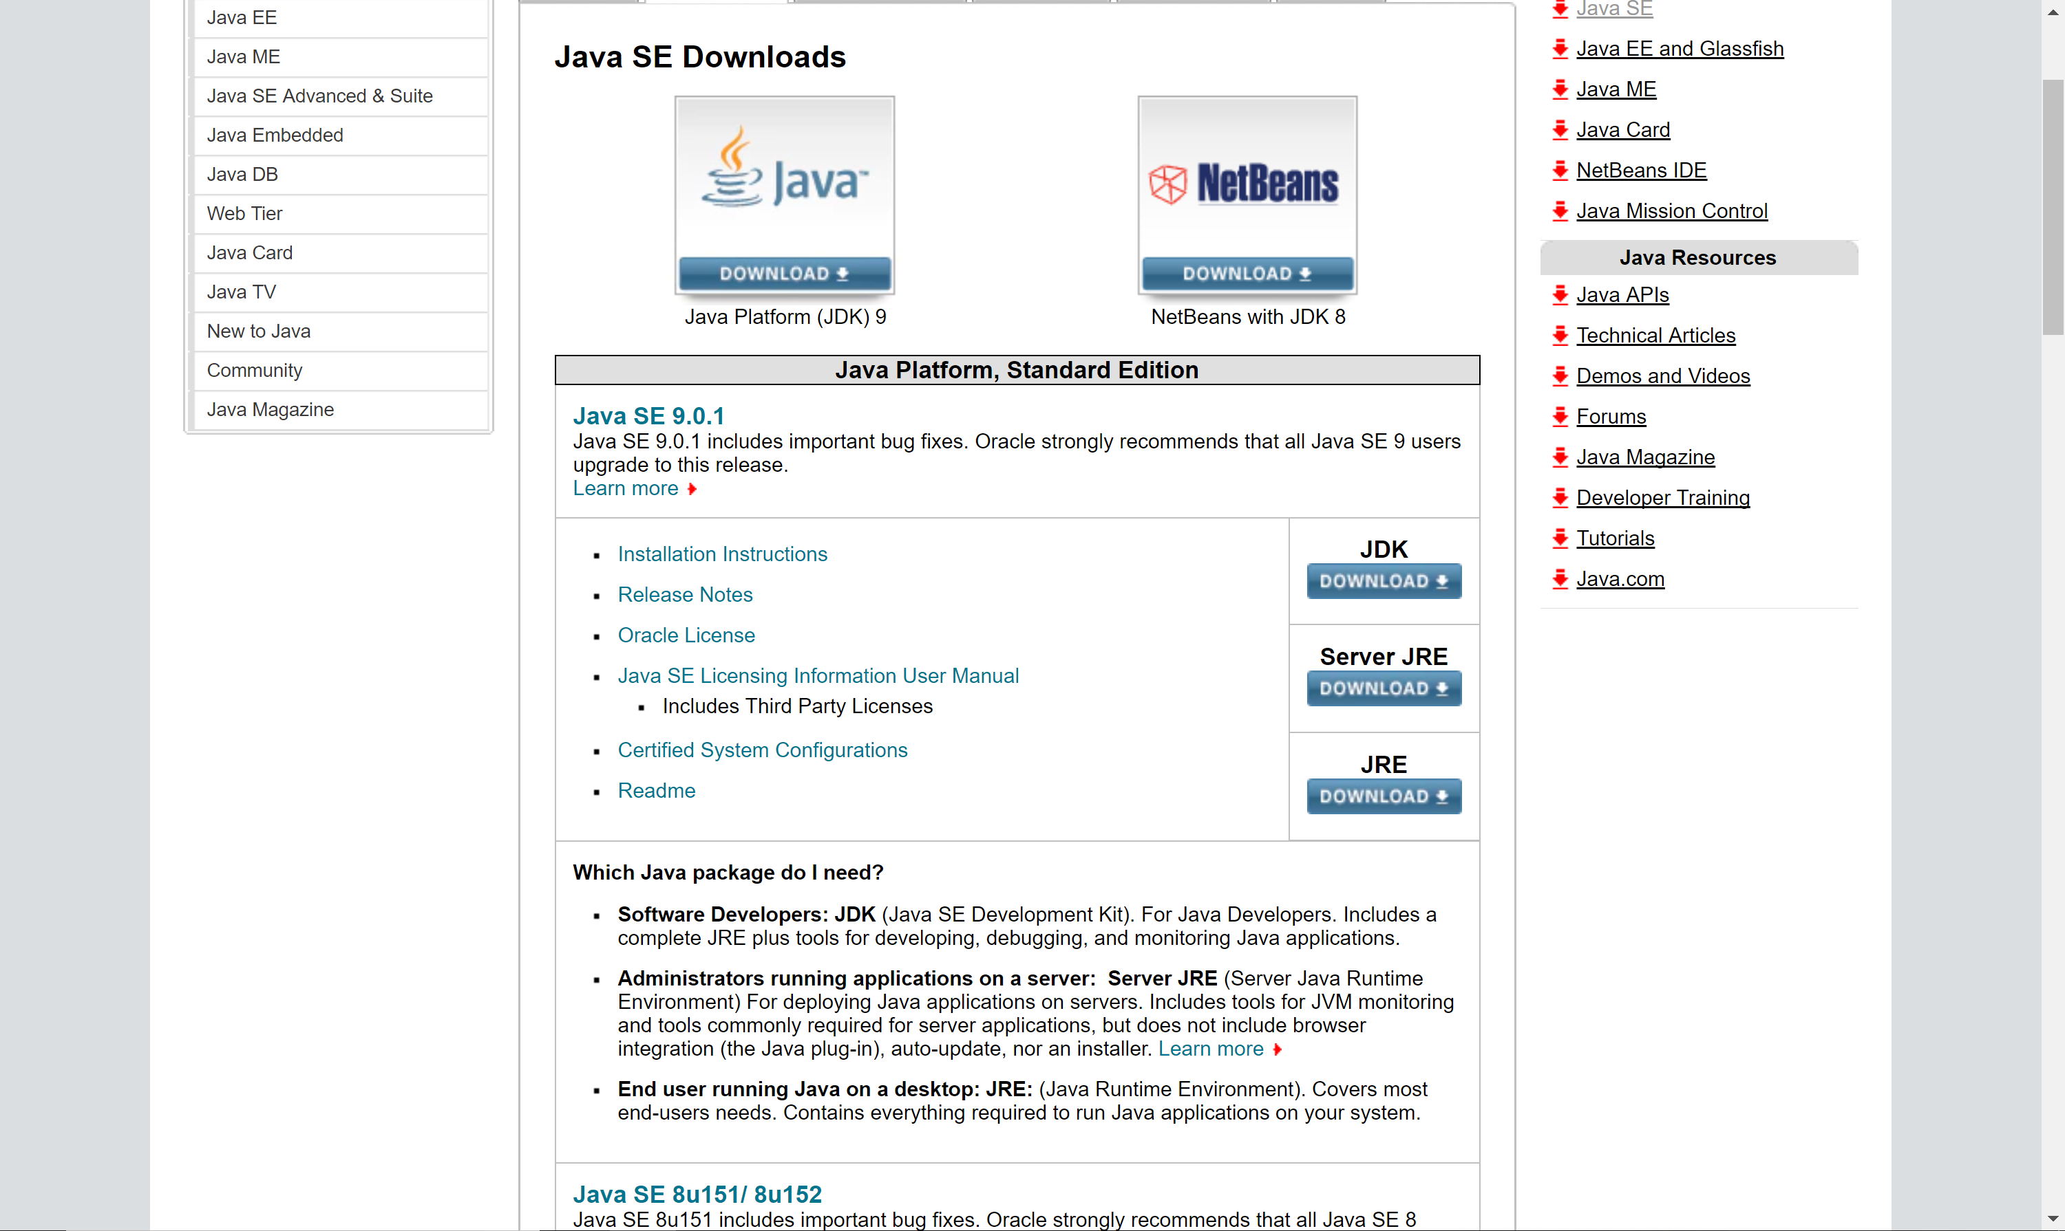

On your computer, in the explorer right click This PC -> Properties -> Advanced System Settings -> Environment Variables and in the System Variables double click PATH

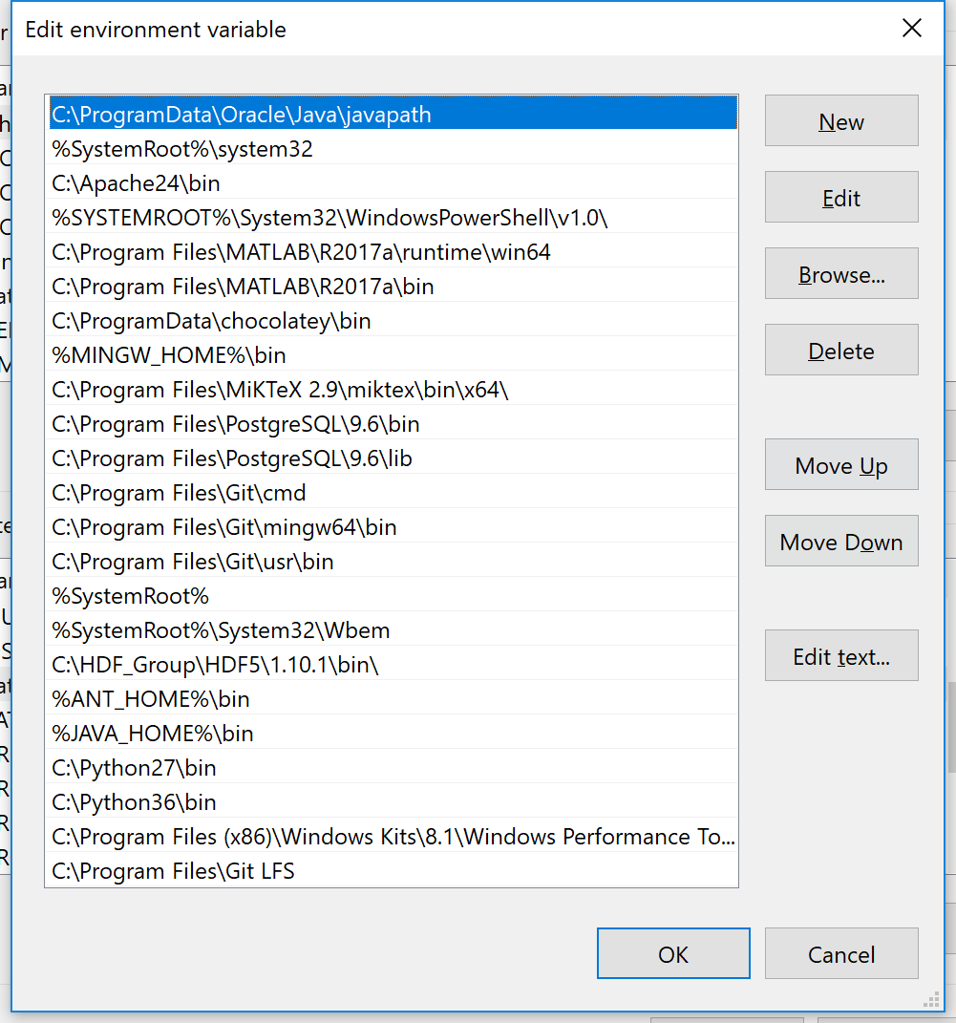

Add the bin path of your JDK and JRE to the PATH, in our case is

“C:\Program Files\Java\jdk1.8.0_151\bin”

And you can also set up %JAVA_HOME% in your system environment. Now go to command window, enter ‘javac’ you can see some options, then you successfully configured JDK.

## TOMCAT 8.0.48

A Tomcat virtual server will help your connect browsers and database.

Download Tomcat on <https://tomcat.apache.org/download-80.cgi>, normally we choose 32-bit/64-bit Windows Service Installer (pgp, md5, sha1, sha512).

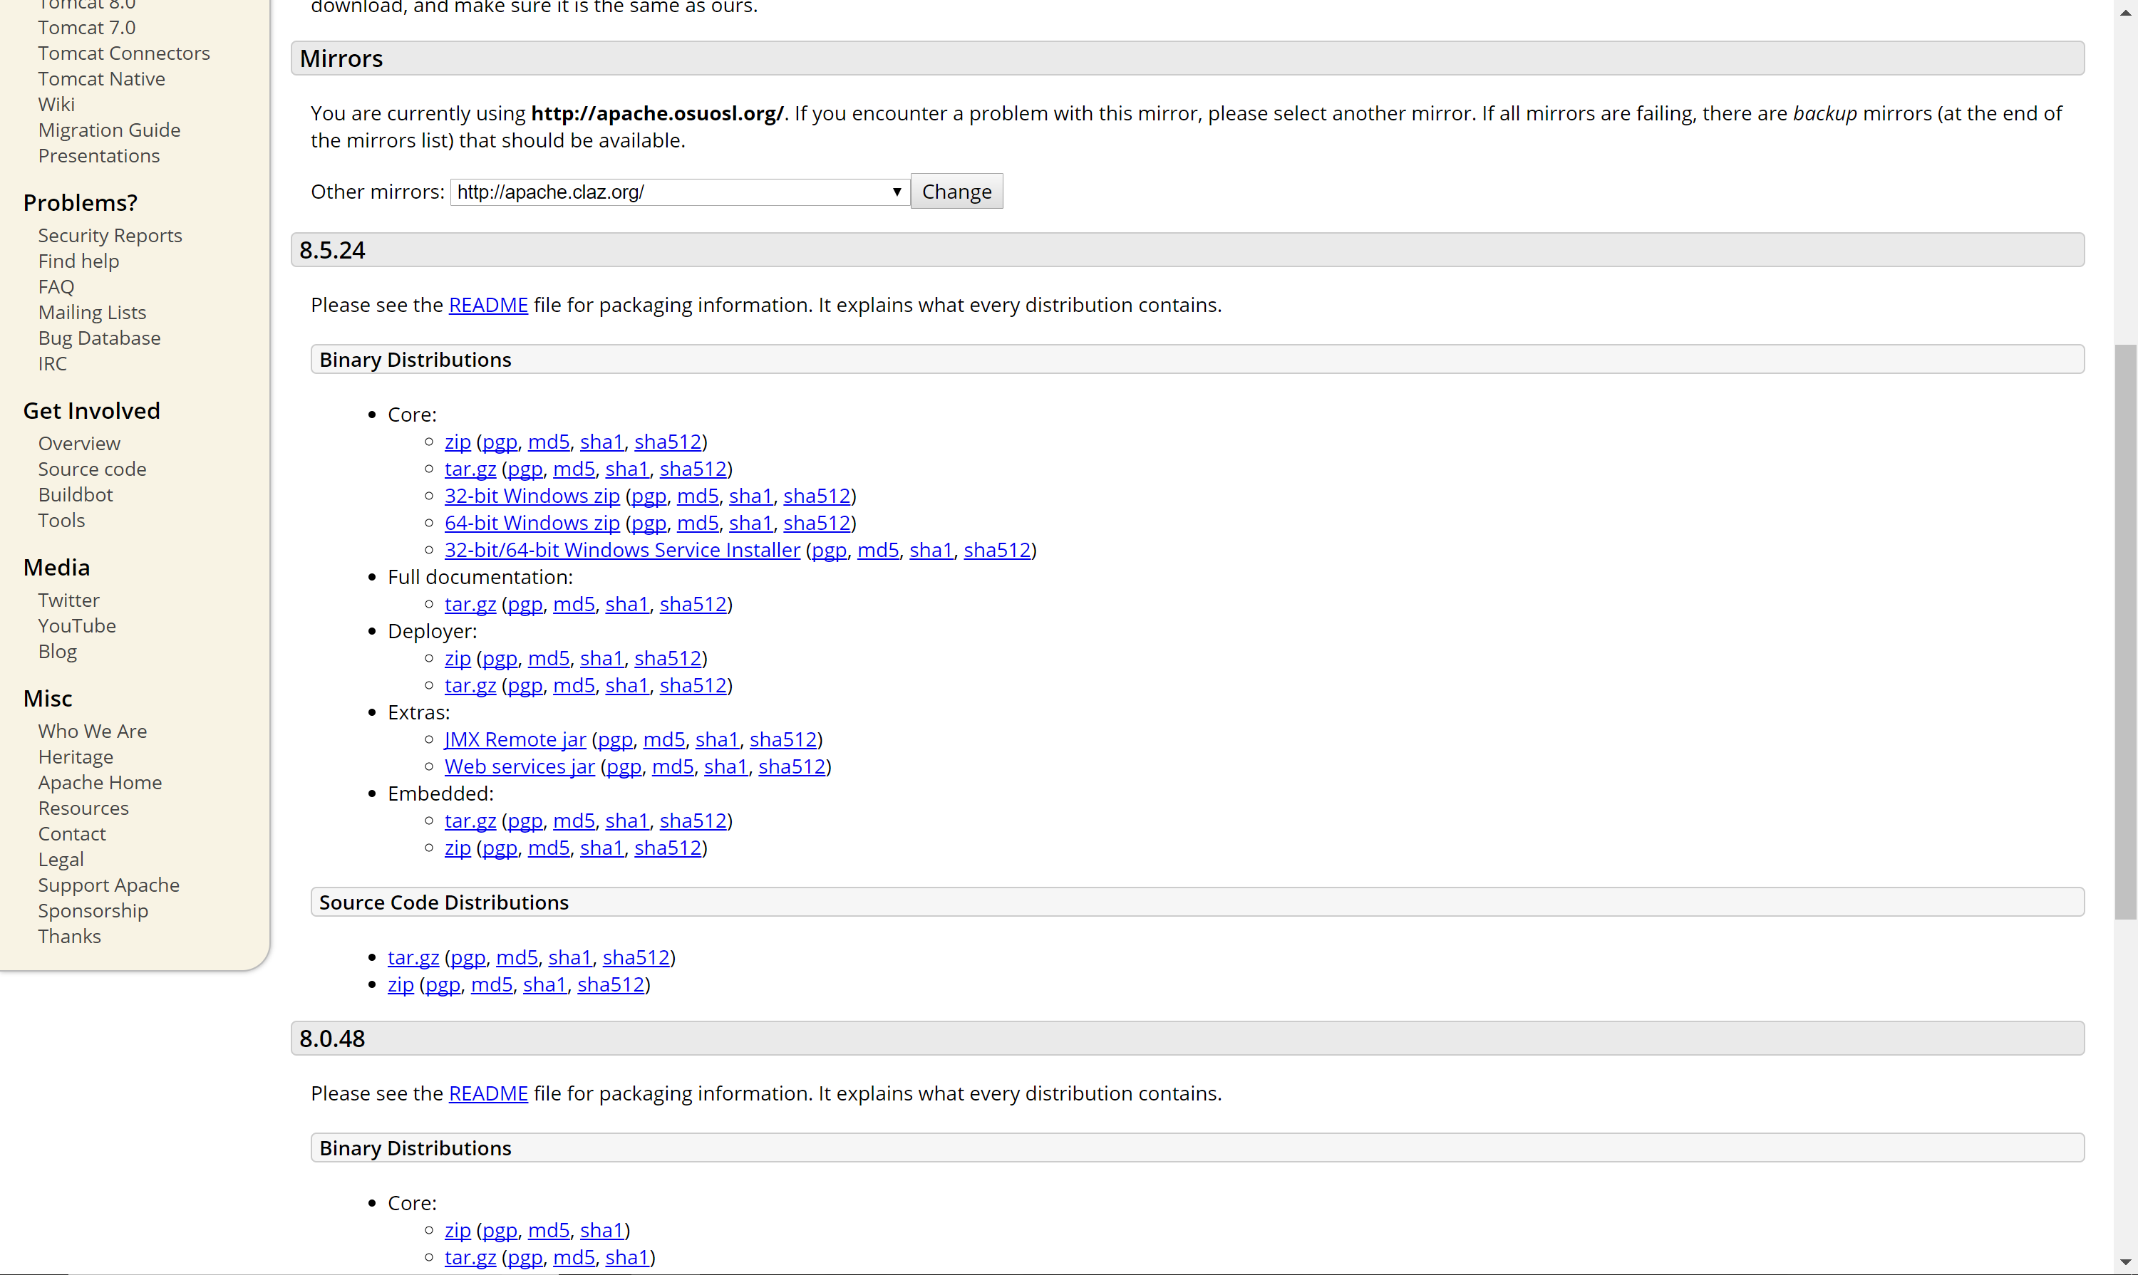

Install the downloaded package and choose to install the full type installation. Set up your User Name and password and click next to finish your installation.

Check the icon on the right bottom, you can use it to start or stop the Tomcat server.

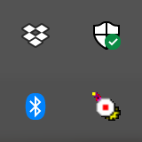

Or you can go to Service, just type ‘Service’ in the search bar of your computer, you can check the status of your Tomcat.

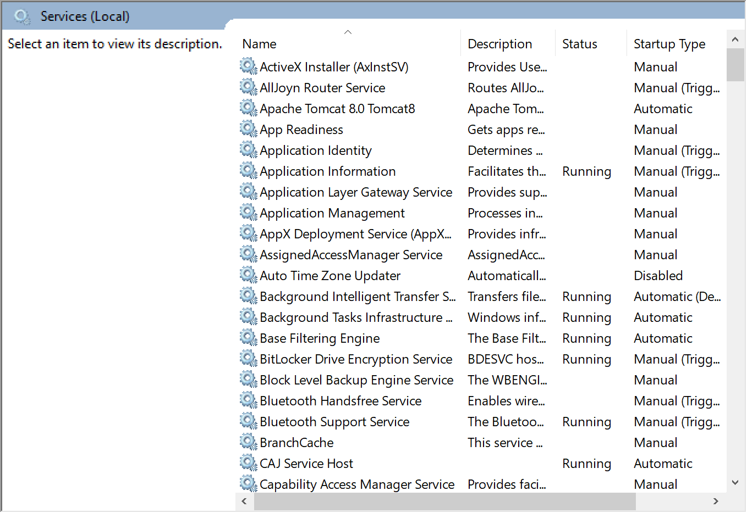

## ECLIPSE IDE FOR JAVA EE DEVELOPER

You’ll need an Eclipse IDE to run or modify your code. You can also use other IDE, Eclipse is what we chose to develop our application.

Download Eclipse on <http://www.eclipse.org/downloads/eclipse-packages/> , choose the version of [Eclipse IDE for Java EE Developers](http://www.eclipse.org/downloads/packages/eclipse-ide-java-ee-developers/oxygen1a) – 64bit.

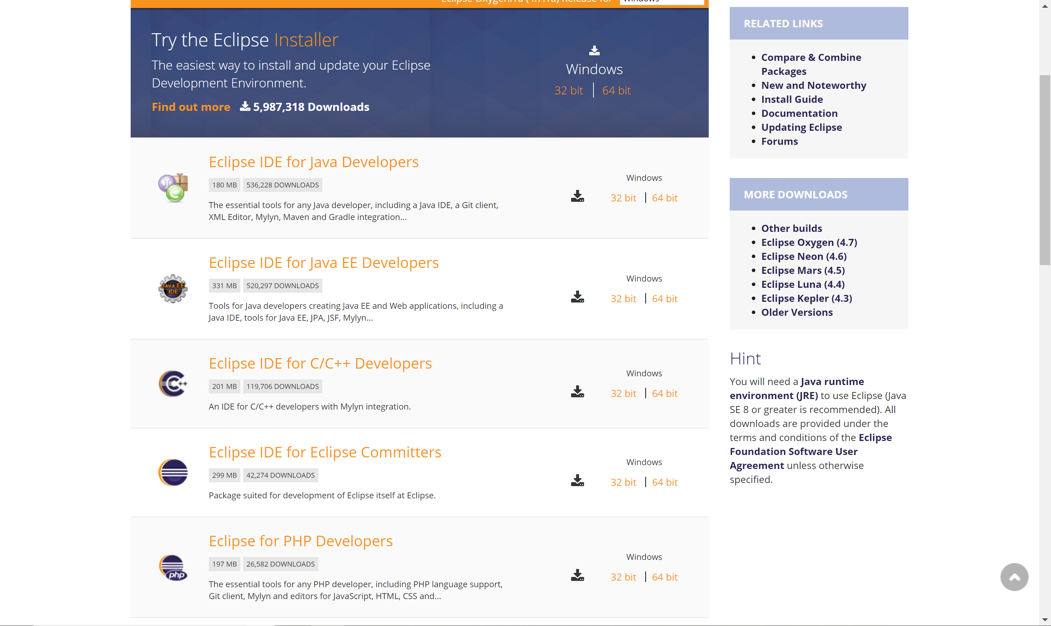

After installing the eclipse IDE, you need to set up a directory in which you store your project, package and classes.

## POSTGRESQL

Postgres is the database system we used, our SQL code is used to manage data from this database system. You can download Postgres from <https://www.postgresql.org/download/> .

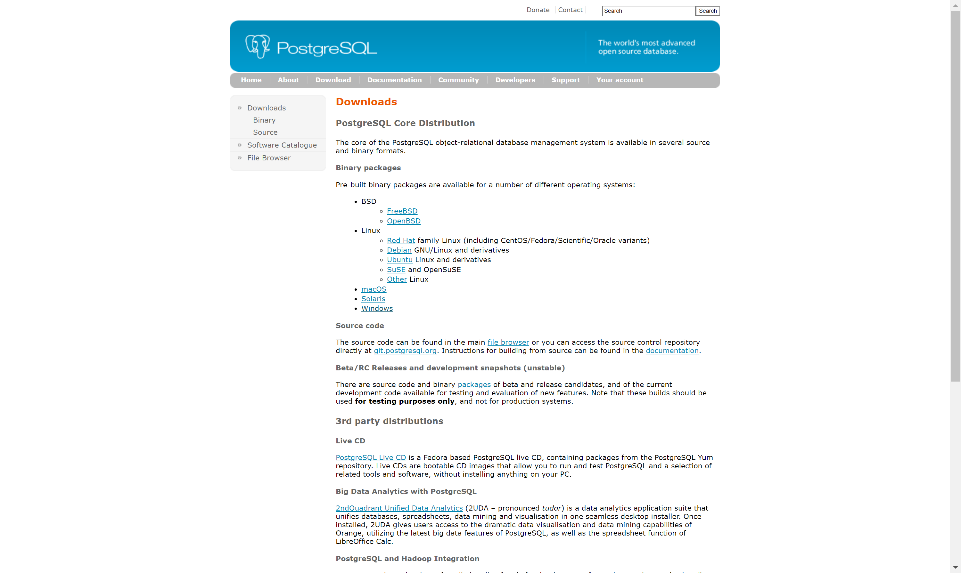

In the process of installation, you will be asked to set up password for your database, which is important since you’ll need this password to manage your data. You can set others to be default and click next to install.

Then you’ll be asked to install some accessories, you can randomly choose one of them and you can download other accessories when you needed (Or it’ll be a really long time to install).

As in JDK, you need to set up your system variable path of postgres. In our case, we need to input the path “C:\Program Files\PostgreSQL\9.6\pgAdmin 4\bin” to the PATH variable. You’ll need to find your path of postgres and find out the bin folder too.

## BROWSER COMPATIBILITY

All browsers that Tomcat server support will be fine to run our application. We tried several versions of browsers and it can be sure that the following browsers will work:

* Google chrome 33+
* Firefox 28+
* Safari 6+
* Internet Explorer 10+